


Project Proposal
Loan Management Web Application
Next.js + Supabase • Modern, Secure, GPS-tracked

Prepared By | NextGen Web Solutions
Date | April 8, 2026
Duration | 2 Months (8 Weeks)
Total Cost | LKR 160,000.00

Executive Summary
NextGen Web Solutions is pleased to present this proposal to design and develop a modern, secure loan management web application for the client. Replacing the current Excel-based workflow, the new Next.js

+ Supabase platform will bring GPS tracking, Email OTP 2FA, multi-loan support and automatic L/B logic into a single, easy-to-use system.

Duration | 2 Months
Total Cost | LKR 160,000
Payment Plan | 30% / 40% / 30%
Stack | Next.js + Supabase

Project Overview
The client currently manages all loan records using Excel sheets. This project will replace that manual workflow with a modern web application built with Next.js and Supabase. The system will allow an Admin and multiple Staff Members to securely log in, manage centers and members, record weekly payments with GPS tracking, and generate daily PDF reports

Technology Stack
  - Frontend / Backend: Next.js 14 (App Router) + TypeScript
  - Database, Auth & Storage: Supabase (PostgreSQL)
  - UI: TailwindCSS + shadcn/ui (mobile-first, user-friendly)
  - Excel Import: SheetJS (xlsx)
  - PDF Reports: jsPDF + autoTable
  - Location: Browser Geolocation API + reverse geocoding
  - Authentication: Email + Password with Email OTP (2FA)

User Roles
Admin — full system access. Creates staff accounts, manages centers and members, imports Excel data, assigns staff to centers per weekday, and views all reports and payment history.

Staff Member — limited access. Can only see centers assigned for the current weekday, collect weekly payments from members, view limited member profiles (last 3 weeks of payments), create new loans for any registered member, and generate daily reports submitted to the Admin.

Authentication
Users log in with email and password. After entering valid credentials, a one-time verification code is sent to their email. The user must enter this code correctly to complete login. Admin creates
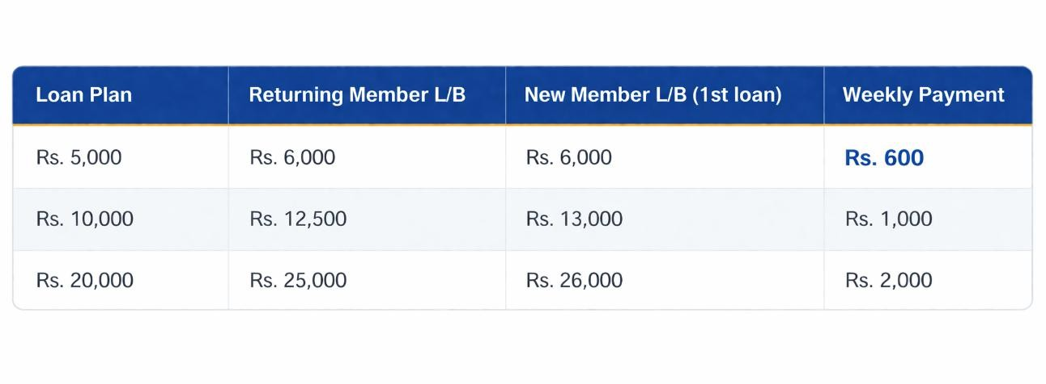
staff accounts with an initial email and password; staff members can change their password from
their profile
5. Loan Plans
A member may hold multiple active loans simultaneously (e.g., 5K + 10K + 20K). Each loan is
tracked separately. A member belongs to only one center. Each member pays once per week on a single day, and staff travel to each member's location weekly to collect payments (members do
not come to the cente
- Core Features
  - Admin Features
    - Dashboard with daily collection, active loans and staff overview
    - Excel sheet import (Center Name, Loan Type, Member Number, Member Name,
L Issued Date, L/B) bulk insert into database • Create / edit centers
    - Create new members with photos and details (admin only)
    - Create staff accounts (email + password)
    - Assign staff to centers per working day (Mon / Tue / Wed / Thu)
  - View all payments with GPS location of where each payment was collected
  - View of completed loans and full payment history
  - Edit core member / loan details (staff cannot edit these)
  - Download CSV exports of all members + full payment history

6.2 Staff Features

- Login with email + password + email OTP

- View only the centers assigned for today (based on weekday)


- View members of the assigned center, separated by loan type (5K / 10K / 20K)

- Collect weekly payments — enter amount paid, or mark N/P if unpaid

- Automatic L/B deduction after each payment

- When a payment is below the expected amount, the member is automatically flagged (shortfall alert)
- GPS location is captured and saved automatically with every payment (fraud prevention)

- Real-time daily collection counter showing total collected today

- View limited member profile — photo, basic details, and the last 3 weeks of payment history

- Create new loans for any registered member (existing L/B does not block new loans)

- Cannot view completed-loan member profiles (admin only)

- Generate the daily PDF report and submit it to the admin

Payment & L/B Logic
Each member pays a fixed weekly amount (Rs. 600 / 1,000 / 2,000) based on the loan plan, on one day per week. Staff travel to each member's location weekly to collect payments. When payment is recorded, the loan's L/B is reduced immediately by the amount paid. When L/B reaches zero, the loan status automatically becomes Completed. If a member pays less than expected, the system flags the payment with a shortfall warning so that staff can quickly identify under-payments.

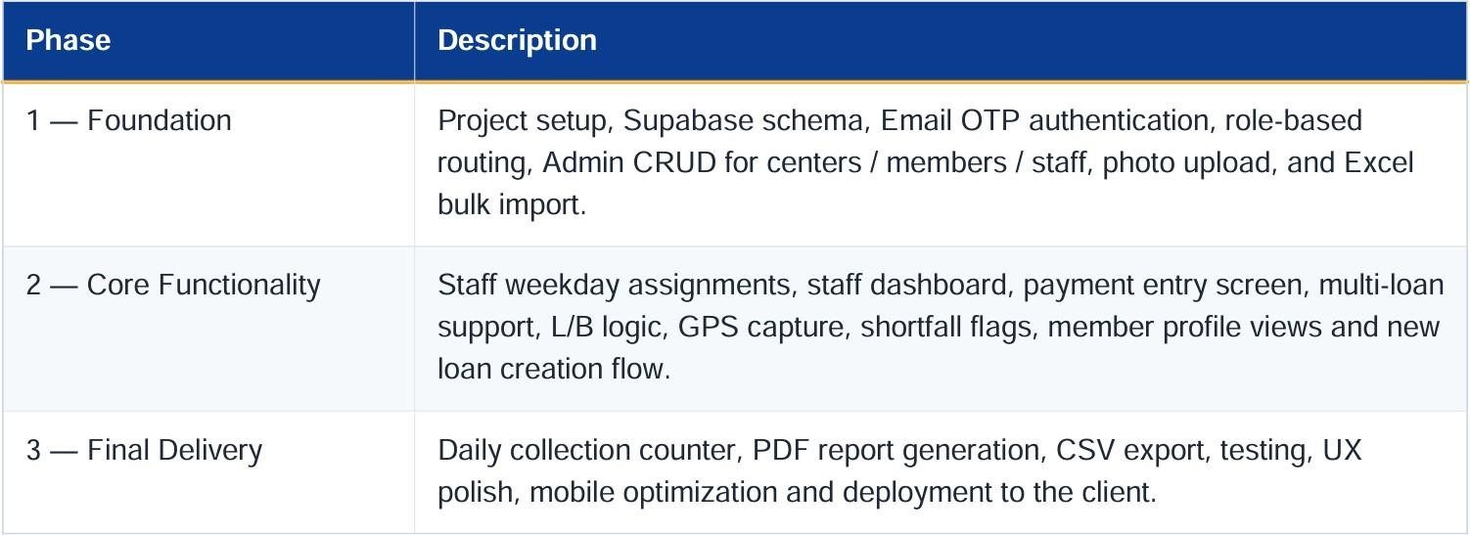

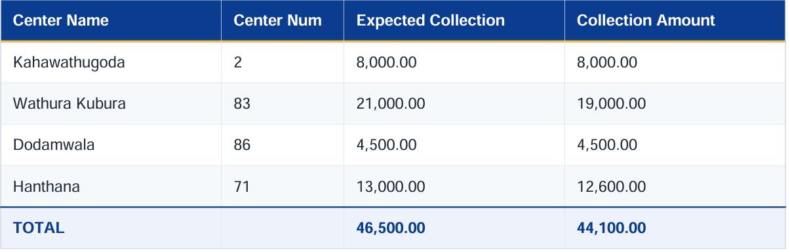

Daily Report (PDF)

Below the table the report includes Total Collection (auto), Cash Issued (manual entry by staff), Loan Issued (manual entry), and Total Cash Balance (auto-calculated). Once generated, the staff member submits the PDF report to the Admin.

Project Timeline


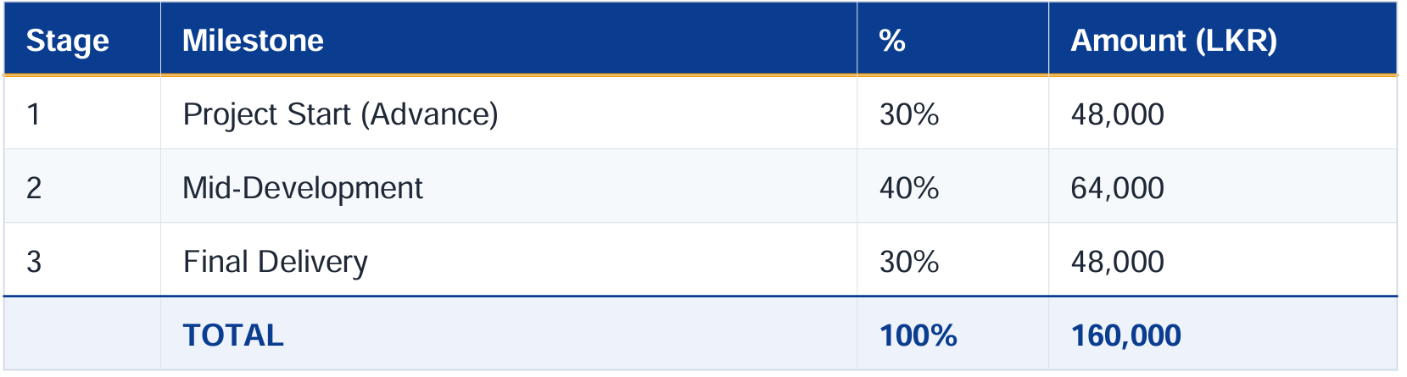
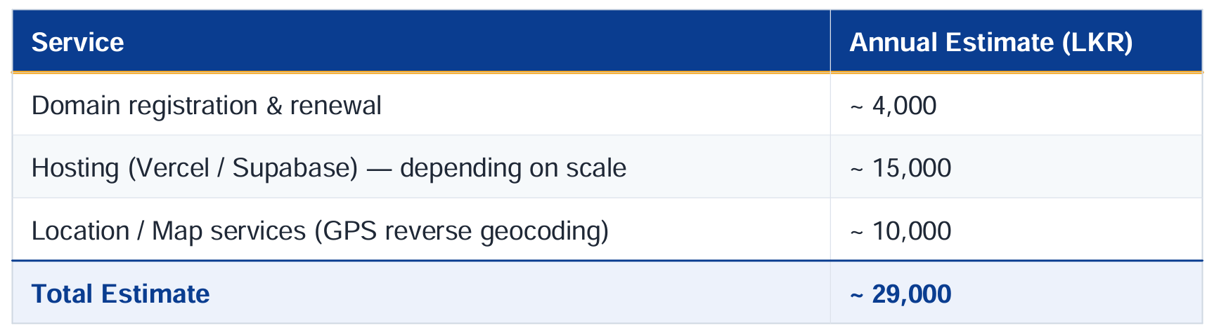
Pricing & Payment Plan

Note: Hosting and domain charges are not included in the project price and must be paid
separately by the client.

Annual External Service Charges (Estimated)
These charges are paid separately by the client. Actual costs may vary based on usage.

- Out of Scope

  - Hosting and domain renewal fees

- SMS gateway integration

  - Custom hardware integration (printers, biometric devices)

12. Acceptance

By making the first milestone payment, the client confirms acceptance of this proposal, the scope of work, the timeline, and the payment terms.
Signatures

 | 
  Client Signature  On behalf of NextGen Web Solutions  Date: April 9, 2026 | Developer Signature  On behalf of NextGen Web Solutions  Date: April 8, 2026

